ROSSMOYNE SENIOR HIGH SCHOOL

Semester One Examination, 2013

Question/Answer Booklet

MATHEMATICS 3A
SOLUTIONS

Section Two:

Calculator-assumed

Student Number: In figures

In words

Your name

Time allowed for this section
Reading time before commencing work: ten minutes
Working time for this section: one hundred minutes

Materials required/recommended for this section

To be provided by the supervisor
This Question/Answer Booklet
Formula Sheet (retained from Section One)

To be provided by the candidate
Standard items: pens, pencils, pencil sharpener, eraser, correction fluid/tape, ruler, highlighters

Special items: drawing instruments, templates, notes on two unfolded sheets of A4 paper, and up to three calculators satisfying the conditions set by the Curriculum Council for this examination.

Important note to candidates

No other items may be used in this section of the examination. It is your responsibility to ensure that you do not have any unauthorised notes or other items of a non-personal nature in the examination room. If you have any unauthorised material with you, hand it to the supervisor before reading any further.

Structure of this paper

Section | Number of questions available | Number of questions to be answered | Working time (minutes) | Marks available | Percentage of exam
Section One:  Calculator-free | 7 | 7 | 50 | 50 | 33
Section Two:  Calculator-assumed | 13 | 13 | 100 | 100 | 67
 |  |  | Total | 150 | 100

Instructions to candidates

- The rules for the conduct of Western Australian external examinations are detailed in the Year 12 Information Handbook 2013. Sitting this examination implies that you agree to abide by these rules.

- Write your answers in the spaces provided in this Question/Answer Booklet. Spare pages are included at the end of this booklet. They can be used for planning your responses and/or as additional space if required to continue an answer.
- Planning: If you use the spare pages for planning, indicate this clearly at the top of the page.
- Continuing an answer: If you need to use the space to continue an answer, indicate in the original answer space where the answer is continued, i.e. give the page number. Fill in the number of the question(s) that you are continuing to answer at the top of the page.

- Show all your working clearly. Your working should be in sufficient detail to allow your answers to be checked readily and for marks to be awarded for reasoning. Incorrect answers given without supporting reasoning cannot be allocated any marks. For any question or part question worth more than two marks, valid working or justification is required to receive full marks. If you repeat an answer to any question, ensure that you cancel the answer you do not wish to have marked.

- It is recommended that you do not use pencil, except in diagrams.

Section Two: Calculator-assumed (100 Marks)
This section has thirteen (13) questions. Answer all questions. Write your answers in the spaces provided.

Working time for this section is 100 minutes.

Question 8 (7 marks)
A sample of 179 cats brought to a veterinary clinic over the course of one month were categorised on the basis of breed and gender as follows:

 | Persian | Ragdoll | Siamese | Other | Total
Female | 19 | 28 | 22 | 18 | 87
Male | 28 | 17 | 26 | 21 | 92
Total | 47 | 45 | 48 | 39 | 179

(a) Complete the missing entries in the table above. (2 marks)

(b) What is the probability that a cat chosen at random from the sample is

(i) a female Siamese? (1 mark)
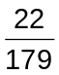

(ii) a male? (1 mark)
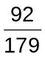

(iii) a Persian or a male? (1 mark)
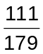

(iv) a Ragdoll, given that they are female? (1 mark)
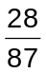

Question 9 (6 marks)
The number of page views of a website per day, following a TV advertising campaign, is shown in the table below.

Day () | 1 | 2 | 3 | 4
Views (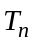) | 275 562 | 91 854 | 30 618 | 10 206

Assume that this pattern continues over the next few weeks.

(a) How many page views are expected on day five? (1 mark)
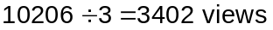

(b) Write a recursive rule for the number of page views per day. (2 marks)
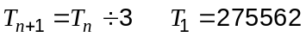

(c) What is the total number of page views of the website after one week? (1 mark)

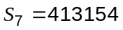

(d) Will the total number of page views reach half a million? Justify your answer. (2 marks)
No. From the rule, 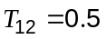and so after day 12 the rule predicts no-one is viewing the website. At this time 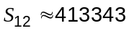 so 500000 will never be reached.

Question 10 (7 marks)
Recent research into introducing a size limit for catches of longtail tuna in Australian coastal waters included the data below from a group of recreational fishermen.

Length (cm) | Number of fish
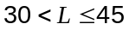 | 4
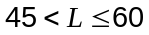 | 1
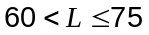 | 4
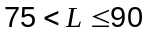 | 11
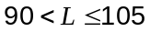 | 18
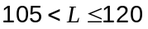 | 12
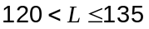 | 1
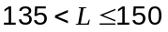 | 1
Total | 52

(a) Draw a histogram for the lengths of longtail tuna. (3 marks)
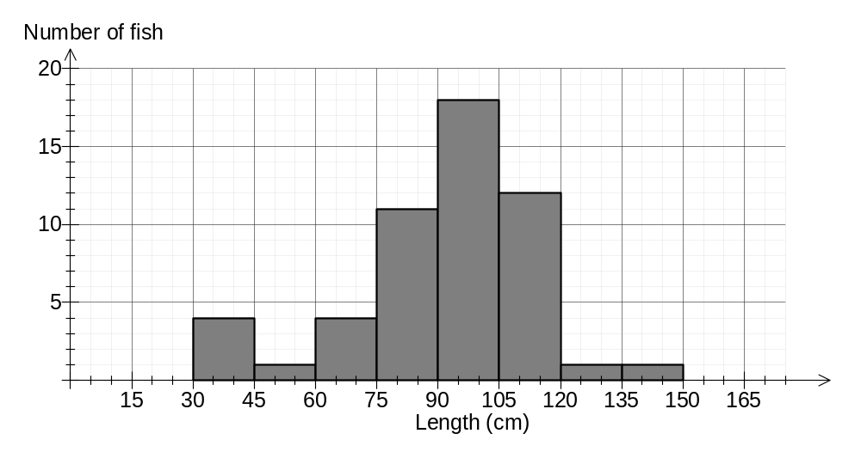
(b) Calculate an estimate for the mean and standard deviation of the lengths of longtail tuna.
(2 marks)
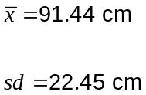

(c) If the original data was available for all 52 longtail tuna, so that the median length could be determined, would you expect it to be the same, smaller than, or greater than the mean length? Justify your answer with reference to the histogram. (2 marks)
Median would be greater than mean, because of the large number of lengths in the LH column of the histogram (negative skew) when compared to the otherwise fairly symmetrical histogram. This group act as an outlier, pulling the mean towards it and away from the median.

Question 11 (7 marks)
Let the universal set U = { 1, 2, 3, 4, 5, 6, 7, 8, 9 }.

Two subsets, R and Q, are such that R = { 2, 3, 5, 7 } and Q = { 1, 3, 5, 7, 9 }.

(a) Determine

(i) 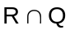 (1 mark)
{ 3, 5, 7 }

(ii) 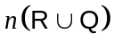 (1 mark)
6

(b) If a number is chosen at random from the universal set, determine

(i) 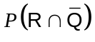 (1 mark)
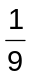

(ii) 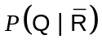 (2 marks)
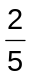

(c) A third subset A is such that 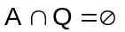, 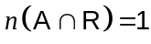 and 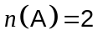. List all such possible subsets for A. (2 marks)
A={ 2, 4} or {2, 6} or {2,8}

Question 12 (6 marks)
A machine fills bags of sugar so that the weights of the bags are normally distributed with a mean of 526 g and a standard deviation of 11 g.

(a) Determine the probability that a randomly selected bag weighs

(i) more than 545 g (1 mark)

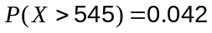

(ii) between 520 and 530 g. (1 mark)

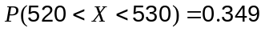

(b) 5% of the bags weigh less than grams. Find the value of , correct to three significant figures. (2 marks)
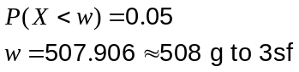

(c) The sugar is packed onto pallets which can hold 440 bags. How many bags on a full pallet would be expected to weigh less than 500 g? (2 marks)

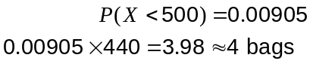

Question 13 (10 marks)
37 students in a school sat a Chemistry test that had a maximum possible score of 40.

The scores of the 19 students in Class M are summarised in this boxplot.

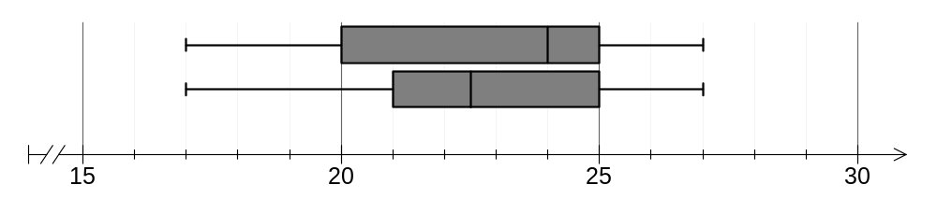
(a) State the interquartile range for the scores of Class M. (1 mark)
5 marks

(b) One student in Class M scored 27 out of 40. If they had scored an extra five marks, would their score be considered an outlier for the class? Justify your answer. (2 marks)

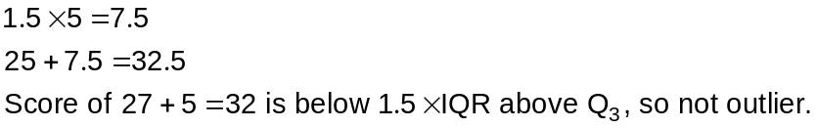

The scores of the remaining students, in Class P, are listed below in ascending order.

17 | 18 | 19 | 20 | 21 | 21
22 | 22 | 22 | 23 | 24 | 25
25 | 25 | 26 | 26 | 26 | 27

(c) Construct a boxplot for these 18 scores on the above diagram, next to that for Class M.
(3 marks)

(d) Explain which class

(i) performed better in the test (2 marks)
Class M - had a higher median of 24 compared to 22.5 for Class P.

(ii) had the least skewed marks (2 marks)
Class P - It's quartiles are fairly equal in width, but Class M has positive skew - width of upper half much less than width of lower half of boxplot.

Question 14 (8 marks)
Two spinners, A and B, are marked with both odd and even numbers.

Spinner A has sides marked 1, 2, 3 and 4 and each score has an equal chance of occurring.

Spinner B has sides marked 6, 7 and 8 and again, each score has an equal chance of occurring.

(a) Draw a tree diagram to show all the ways spinner A and spinner B could stop. (3 marks)

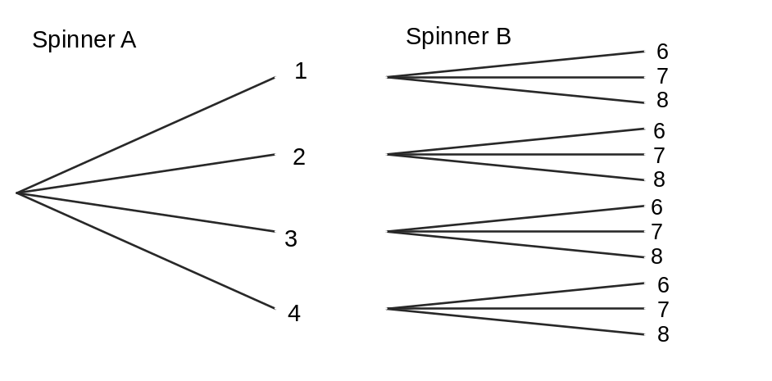

(b) Determine the probability that

(i) both spinners stop on even numbers. (1 mark)
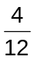

(ii) one spinner stops on an even and the other stops on an odd number. (1 mark)
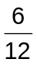

(iii) spinner A or spinner B stops on an even number. (1 mark)
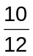

(iv) both spinners stop on an odd number, given that at least one spinner has stopped on an odd number. (2 marks)
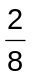

Question 15 (6 marks)
A remotely controlled drone flies at a constant speed of 40 m s⁻¹ above level ground and at a steady height, directly towards a tower.

At one point during the flight, the operator of the drone noted that the angle of depression to the base of the tower was 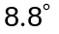. Eight seconds later, this angle had increased to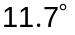.

Calculate, to the nearest metre, the height the drone was flying at.

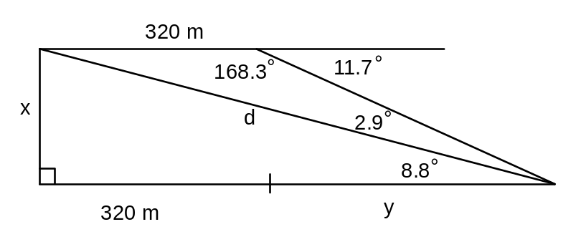

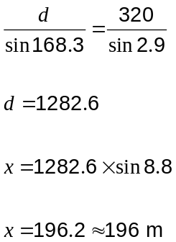

Question 16 (7 marks)
(a) In a science experiment, quantity was observed to be related to the another quantity by the equation 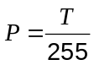.

(i) Describe the relationship between and . (1 mark)

P is directly proportional to T

(ii) Sketch the relationship between and . (2 marks)
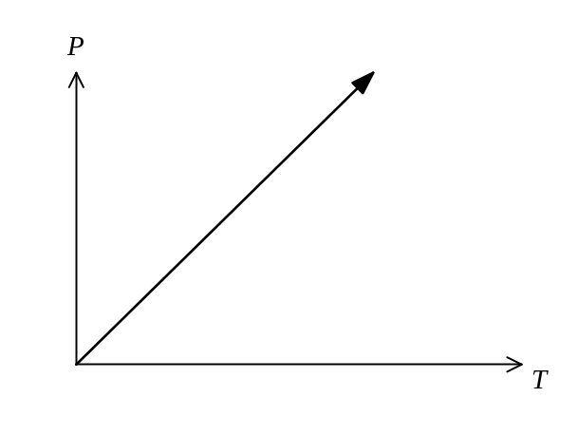
(b) In another experiment, the quantity was observed to be related to the another quantity by the equation 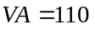.

(i) Calculate when 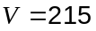. (2 marks)

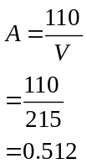

(ii) Sketch the relationship between and . (2 marks)
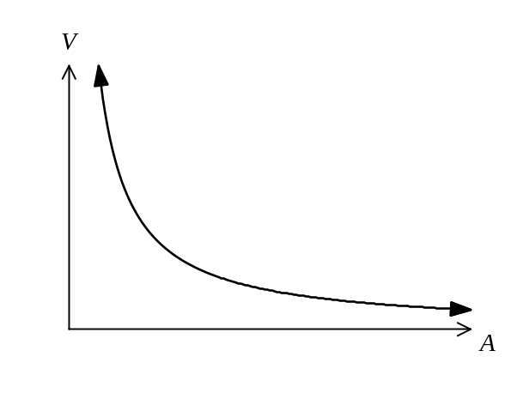
Question 17 (12 marks)
Two functions are given by 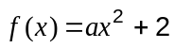 and 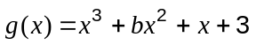, where and are constants.

 has a root at 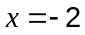 and 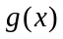 passes through the point (2, -3).

(a) Show that 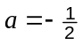. (2 marks)
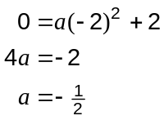

(b) Show that 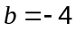. (2 marks)
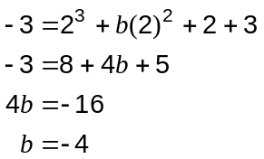

(c) Sketch the graphs of 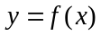 and 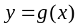 on the axes below. (5 marks)
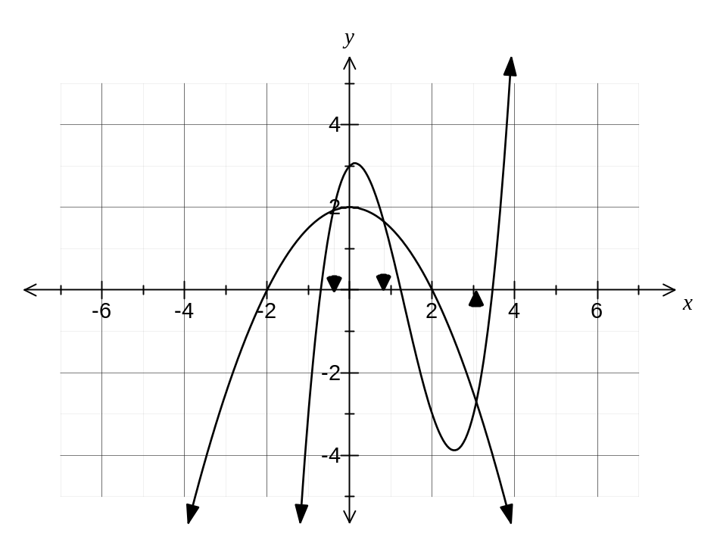
(d) Solve 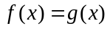, giving your solution(s) rounded to two decimal places. (2 marks)
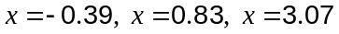

(e) Show how your graph can be used to obtain the solutions to (d). (1 mark)
See graph - must clearly indicate -coordinate only.

Question 18 (5 marks)
Using the digits 1, 2, 3, 4 and 5, with no digit used more than once, how many integers between 1000 and 9999 can be made if

(a) there are no other restrictions? (1 mark)
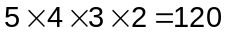

(b) the number must begin with the digit 5? (1 mark)

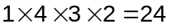

(c) the number must be even? (1 mark)

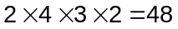

(d) the number must begin with the digit 5 and be even? (1 mark)

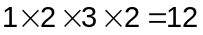

(e) the number must begin with the digit 5 or be even? (1 mark)

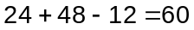

Question 19 (11 marks)
A loan of $2300 is to be repaid by monthly payments of $220. Interest, of 9.6% pa of the balance, is added at the end of each month, just before the repayment is made. The table below shows the balance of the loan at the start and end of each month, together with the monthly interest and repayment for the first few months.

Month | Balance (Start of month) | Interest | Repayment | Balance (End of month)
 |  | 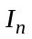 | 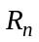 | 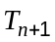
1 | 2300.00 | 18.40 | 220.00 | 2098.40
2 | 2098.40 | 16.79 | 220.00 | 1895.19
3 | 1895.19 | 15.16 | 220.00 | 1690.35

(a) Write a recursive rule to determine the amount of the loan at the start of month .
(2 marks)
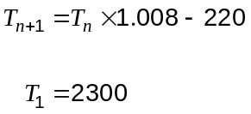

(b) At the end of which month is the loan repaid in full, and what is the amount of the final repayment? (2 marks)
Month 11.

Final repayment is $211.53

(c) How much interest is paid over the life of this loan? (2 marks)

(d) Show that the total interest over the life of the loan approximately doubles when the repayment is halved to $110 per month. (3 marks)
Now takes 23 months, with final payment of $106.99.
Total interest is , which is just over double previous figure.

(e) If the repayment was repeatedly halved, would you expect the interest to roughly double each time? Explain your answer. (2 marks)
No. Once the repayment has been halved three more times, it is less than the first month's interest, and so the loan would never be paid off, with interest accruing for ever.

Question 20 (8 marks)
The graph of the function is shown, with a root at (4, 0) and -intercept at (0, 2).

The hyperbola has asymptotes with equations 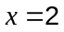 and 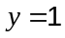.
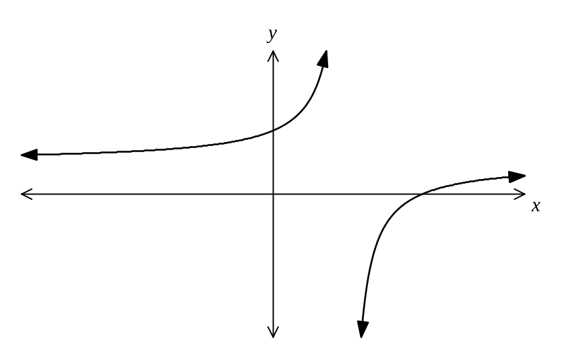
Determine the

(a) coordinates of the root of the graph 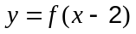. (2 marks)

Was (4, 0)
Becomes (6, 0)

(b) equation of the horizontal asymptote for the graph of 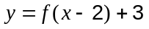. (2 marks)
Was
Becomes 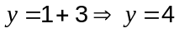

(c) equation of the vertical asymptote for the graph of 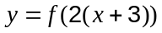. (2 marks)

Was
Becomes 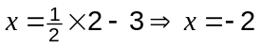

(d) coordinates of the -intercept of the graph 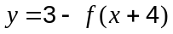. (2 marks)

Need to consider known root at (4, 0)
Becomes 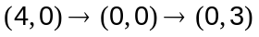

This examination paper may be freely copied, or communicated on an intranet, for non-commercial purposes within educational institutes that have purchased the paper from WA Examination Papers provided that WA Examination Papers is acknowledged as the copyright owner. Teachers within purchasing schools may change the paper provided that WA Examination Paper's moral rights are not infringed.

Copying or communication for any other purposes can only be done within the terms of the Copyright Act or with prior written permission of WA Examination papers.

Published by WA Examination Papers
PO Box 445 Claremont WA 6910

